Dungeon Game Improvement Documentation

Actual Implementation Selection:
- (1) Factory Pattern: DungeonRoomCreator interface with creators for spawn rooms, regular rooms, boss rooms, and key rooms.
  - KS-1, KS-7
  - This needs to be added because currently the DungeonRoom class violates the Single-Responsibility principle in a major way because it is currently responsible for the creation of 4 different room types.
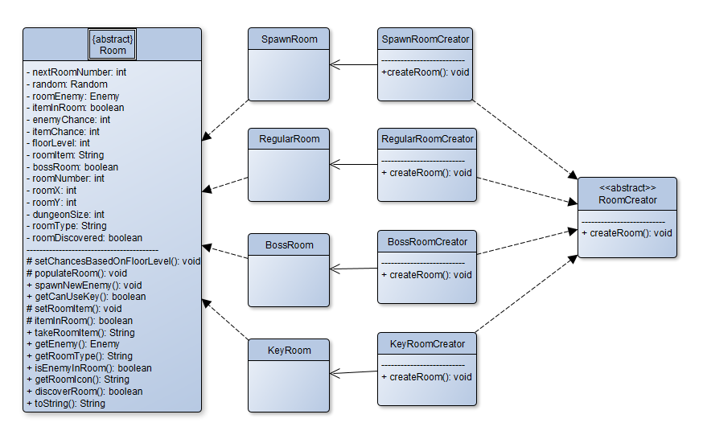
  - UML:

  - Coding Example:
- public abstract class RoomCreator {
- public abstract DungeonRoom createRoom();
- }

- public class SpawnRoomCreator extends RoomCreator {
- public Room createRoom() {
- Room room = new SpawnRoom();
- return room;
- }
- }
- (2) Command Pattern: Commands to handle player and enemy health and level changes.
  - KS-22
  - This needs to be added to abstract the handling logic of health and level changes from the client in a way that puts the handling of such logic in the same place for both enemies and players (StatsController would hold the place of each set of commands).
  - UML:
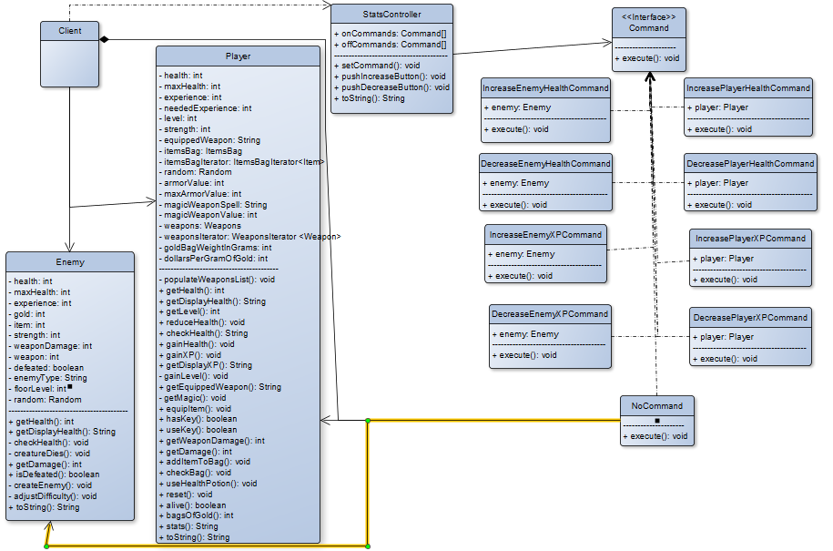
  - Coding Example:

- public class IncreaseHealthCommand {
- Player player;

- public IncreasePlayerHealthCommand (Player player) {
- this.player = player;
- }

- public void execute() {
- player.gainHealth();
- }
- }
- (3) Façade Pattern: could be used to abstract logic away from the user/client. For instance; moving things like enterDungeon() into a DungeonFacade.
  - KS-17
  - This needs to be added to support abstraction from the user and simplification of main logic.
  - UML:
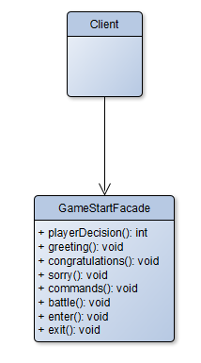
  - Coding Example:
- public class OubliettesofPeril {
- DungeonFacade dungeonFacade = new DungeonFacade();

- dungeonFacade.startGame();
- //This method contains the methods:
- //playerDecision(), greeting() which then link to
- //the other necessary methods in the facade
- }

Overall UML:
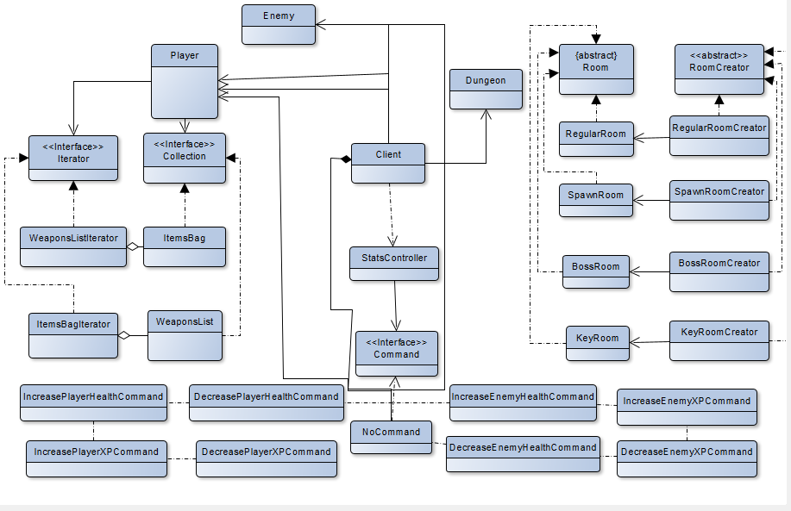
Additional Possible Implementations:
- Decorator Pattern: Wrap weapons in magic buffs, weapons, etc. and also for text wrapping.
  - KS-13, KS-18, KS-21
  - This could be implemented to make adding buffs and weapons to classes easier as well as easier printing logic for effects.
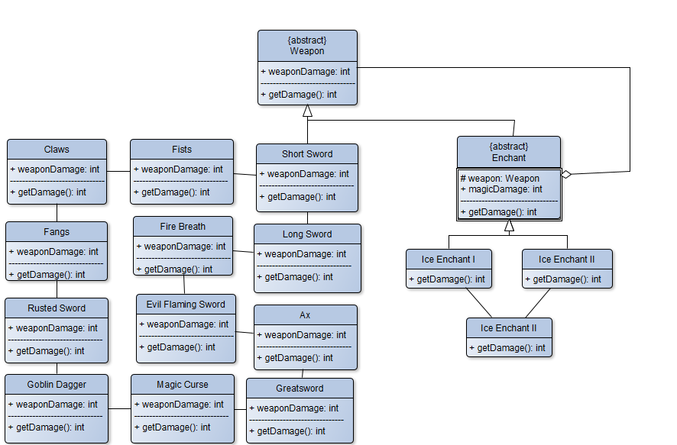
  - UML:
  - Coding Example:
- public abstract class Enchant extends Weapon {
- protected Weapon weapon;

- public abstract int getDamage();
- }

- Factory Method Pattern: Used to create each specific type of enemy by extending the Enemy class into objects like an Ogre class.
  - KS-11
  - This needs to be added because currently the Enemy class violates the Single-Responsibility Principle as it is responsible for the creation of many different enemy types as well as changing enemy stats.
  - P.S. Another way to ensure the single-responsibility principle is to make an enemy interface and implement it with various enemy type classes. This is what I would actually go with in this case for simplicity.
  - Coding Example:
- public class SkeletonKnight extends Enemy {
- public SkeletonKNight () {
- name = 'Skeleton Knight';
- maxHealth = 12;
- health = 12;
- strength = 2;
- weapon = "rusted sword";
- weaponDamage = 4;
- experience = 9;
- }

- public int getMaxHealth() {
- return maxHealth;
- }

- public int getHealth() {
- return health;
- }

- public int getStrength() {
- return strength;
- }

- public String getWeapon() {
- return weapon;
- }

- public int getWeaponDamage() {
- return weaponDamage;
- }

- public int getExperience() {
- return experience;
- }
- }
- Iterator Pattern: Enable iteration through the items in the player’s bag
  - KS-20
  - This needs to be added to most efficiently access collections of items. Especially with two different collections present: the player’s item bag and weapons.
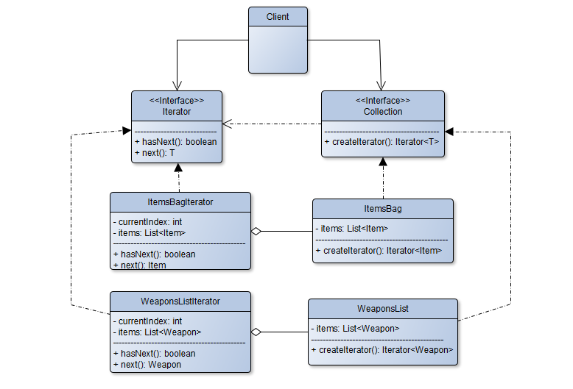
  - UML:

  - Coding Example:

- import java.util.NoSuchElementException;

- public class ItemsBagIterator implements Iterator<Item> {
- private int currentIndex = 0;
- private List<Item> items;

- public ItemsBagIterator(List<Item> items) {
- this.items = items;
- }

- @Override
- public boolean hasNext() {
- return currentIndex < items.size();
- }

- @Override
- public Item next() {
- if (!hasNext()) {
- throw new NoSuchElementException();
- }
- return items.get(currentIndex);
- }
- }

Extended Notes:
- I think the first implementation of Factory Pattern helped to overall support single responsibility and also to break up the code to increase understand and also not make a single class so long (a side effect I did not even account for).
- The second implementation of a controller for the stats of both the player and enemy class could definitely be leveraged more in a different setup where more of the health aspect was controlled directly outside of the player and enemy classes but abstract and setting one place for everything to be accessed is great for later use and abstraction.
- The third implementation I originally wanted to include every method in the main but I actually found that there were a few that belonged in main (the playerDecision, battle, and exit methods) as they supported the player input usage directly so those ones I kept outside during actual implementation. The ones more solely about game mechanics I hid.

